Advances in Mechanical and Materials Engineering
Volume xx, 202x, Pages xx-xx
https://doi.org/10.7862/rm.202x.xx

Original Research/Review
Paper Title – Formatting Requirements
Firstname Lastname ¹ , Firstname Lastname ^{1,2}, Firstname Lastname ^{2,}*
¹ Department, Institution, Street, City, Country
² Department, Institution, Street, City, Country
* Correspondence: example@example.com, tel.: (optional; include country code)
Received: xx Month 2023 / Accepted: xx Month 2023 / Published online: xx Month 2023
Abstract
This is an obligatory part of the paper which should summarise the content of the paper. Please provide an abstract of 100 to 200 words.
Keywords: keyword 1, keyword 2 (between 3 and 5 keywords)

Preparation of the text
This document outlines a number of guidelines concerning the preparation of papers that will be published in the Advances in Mechanical and Materials Engineering. Please make sure your text is prepared using a Microsoft Word template. Please use Microsoft Word 2007 or later. The details related to the preparation of your papers are given below.

General comments
In order to stick to the required formatting details please use this template, the proposed styles and make sure you do not change them (11 pt, Times New Roman, first line of each paragraph indented by 0.75 cm, justified, single line spacing, automatic word hyphenation).)
    - Basic information about the paper
Please prepare some basic information linked to the paper’s title, the authors’ names and their affiliations as well as the details about the corresponding author. This should be done in accordance with the requirements provided in this template. Please remember to fill in the information in the header (authors’ name(s) [initials Lastname, example: J. Dun, J. Y. Wang] on even-numbered pages, the paper title on odd-numbered pages except for the first page). Please do not include page numbers in the footer and do not include line numbers.
Our preference is for papers written in English, however, if you want to publish a paper written in Polish, please feel free to contact the Editor to provide arguments supporting your point of view. Please use British English or American English but avoid mixing them in one paper. Advice from someone who provides professional language editing services or is a native speaker is recommended.

Types of papers and the review process
Usually, the most common types of papers accepted for publication in the Advances in Mechanical and Materials Engineering are full papers (8–20 pages). All submitted papers are reviewed by at least two reviewers and we use a single blind review policy. The scope of the journal covers:
- automation and robotics,
- aviation and astronautics,
- materials engineering,
- mechanical engineering,
- metallurgy,
- production engineering,
- structural engineering.
Our review policy assumes that once the paper is delivered through the submission system it is forwarded to reviewers within two weeks and they have no more than three weeks to prepare their review. This procedure ensures the whole decision-making process should be finalised within 45 days. Depending on the reviewers’ comments the final decision can be:
- Reject submission – there is no possibility of resubmission,
- Revisions required – author(s) is/are requested to revise their paper according to the reviewers’ suggestions and then resubmit the paper; this option is taken when some substantial changes are required,
- Accept submission – this decision is taken when the author(s) have fulfilled all the required reviewers’ comments (they accept the paper for publication) and met all the necessary editing requirements.
We publish papers of significant scientific content which are granted at least two positive reviews. Such papers can also contain case studies, the outcomes resulting from active cooperation between university members and a company’s staff, the result of the work performed in collaboration with students and young scientists, or conclusions drawn from participating in an international research network. We also warmly welcome papers related to historical events, memories, reviews, comments, and any other activities connected with mechanical and materials engineering and its applications.

The structure of your paper
Your paper should be divided into sections and subsections. Depending on the topic under consideration please feel free to use as many sections and subsections as needed. While doing so, remember to use the appropriate formatting requirements and avoid subsections that consist of several sentences. It is recommended to use the first section as an introduction to the subject followed by your main contribution. The paper should be concluded in the last section.
If you want to write paragraphs including bullet points, please use the following format:
- item,
- item,
- item.
If you want to write paragraphs including numbered bullet points please use the following format:
- numbered item,
- numbered item,
- numbered item.

Figures, equations and tables
Below you will find the necessary information for including graphics, equations and tables.

Including graphics
Vector graphics is the preferred format for any graphics files. If this is not possible, please use bitmap files saved as .png files with a resolution of 300 dpi. Please make sure all the details in your image are visible at the required resolution. Each figure should contain a successive number and a clear and concise description. Remember, you should refer to each figure (e.g., Fig. 1) at least once in your paper.

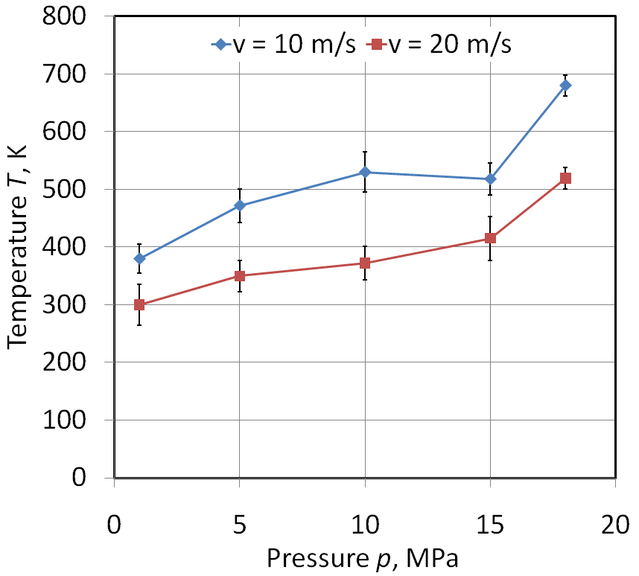
Fig. 1. Description of figure (9 pt, Times New Roman)
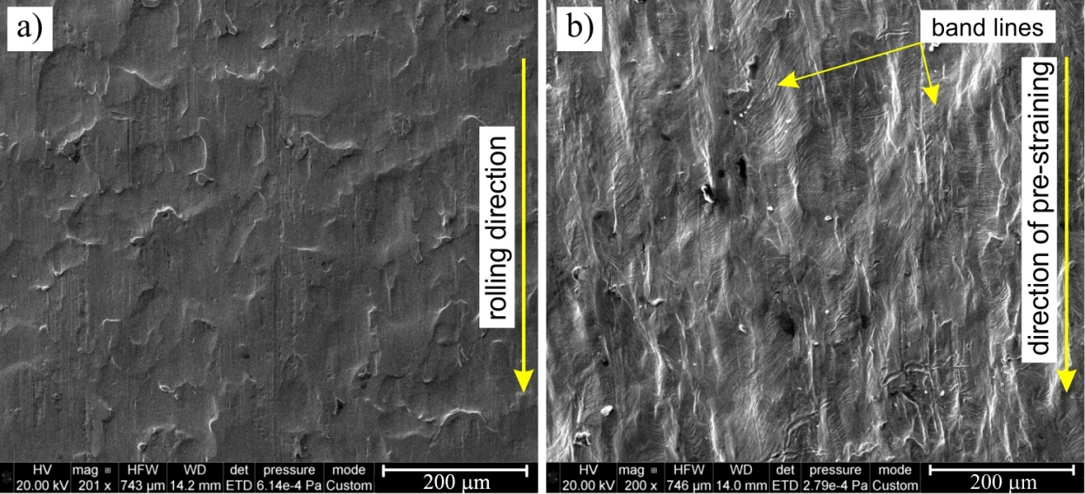
Fig. 2. The SEM micrograph of a) original surface of DC04 sheet and b) surface of sheet pre-strained at ε_{p} = 0.24

Inserting equations
When you want to include an equation, please use a Microsoft Word built-in equation editor. Please make sure that all equations are provided in an editable Word format. Remember that if you refer to such an equation you should do this using parentheses – for example (1). Equations should be left aligned and set on a separate line. They should be numbered consecutively in the right margin for reference. Please do not include section numbers in the equation numbering.
$∆F+∆g+∆r_{w}=0$ (1)
In the case of real numbers presented in the paper please use dot (.) as a decimal separator instead of comma (,), so it should be 12.34 instead of 12,34.
All names of variables given in the text should be written in italics (for example: X, x) unless they represent vectors (for example: X, x).

Inserting tables
If you include tables, please use the format shown in Table 1. Each table should contain a consecutive number, the title of the table and appropriate content.

Table 1. The title of the table
Title of column | Title of column | Parameter, unit
Item 1
Item 2
Item 3 ¹
¹ Tables may have a footer.

Literature references and citations
In References section you can add literature references with the required bibliographic information. The journal adopts the citation standards of the APA Style. APA Style uses parentheses in citations to present supporting information important for a work's identification and retrieval. The reference list should be included at the end of the paper.
In APA Style the reference list is arranged in alphabetical order by the authors' surnames. Always include the issue number for a journal article. Include the DOI at the very end of an APA reference entry.
If a reference has no author, list it alphabetically according to the title. Ignore the words ‘A’, ‘An’ and ‘The’ at the beginning of a corporate author or title for deciding where it fits alphabetically. If there are two (or more) references by the same author, list them in order of publication date with the older one first.
If references by the same author have been published in the same year, list them alphabetically by title. The letters ‘a’, ‘b’, etc. are placed after the year, for example (2011a), (2011b).
Examples:
- Parenthetical citations: (Brown, 2014; Oshima et al., 2015a),
- Narrative citations: Brown (2014), Oshima et al. (2015a).
For non-Roman scripts, you must: (i) provide a transliteration of the script into the English alphabet and (ii) provide an English translation of the title in brackets.

Acknowledgments
If you want to add something extra to your paper, express your gratitude for the support received or show some details related to the paper’s financing please use this section.
References
American Psychological Association. (2022). Creating an APA Style reference list guide. https://apastyle.apa. org/instructional-aids/creating-reference-list.pdf
Comella-Dorda, S., Dean, J. C., Morris, E., & Oberndorf, P. (2004). A process for COTS software product evaluation (No. CMU/SEI-2003-TR-017; pp. 86–96). Retrieved from Software Engineering Institute, Carnegie Mellon University website: https://resources.sei.cmu.edu/library/asset-view.cfm?assetid=6701
Giglier, S.W. (2019). Measurement of moisture content in lubricating oils. In F. R. Pharr, N. Hill, & W. Spechts (Eds.), Waste lubricating oils (3rd ed., pp. 19–84). Scientific Publishing.
Ibrahim, I.J., & Yapici, G.G. (2018). Application of a novel friction stir spot welding process on dissimilar aluminum joints. Journal of Manufacturing Processes, 35, 282-288. https://doi.org/10.1016/j.jmapro. 2018.08.018
International Organization for Standardization. (2005). Notch tensile test to measure the resistance to slow crack growth of polyethylene materials for pipe and fitting products (PENT). (ISO 16241:2005). https://www.iso.org/standard/32163.html
Korthauer, R. (2018). Lithium-ion batteries: Basics and applications. Springer.
Lutyy, I.V. (2015). Elektroshlakovaya plavka i rafinirovaniye metallov [Electroslag smelting and refining of metals]. Nauk. Dumka, 7(5), 22–24.
Marciniak, Z., Duncan, J.L., & Hu, S.J. (2002) Mechanics of sheet metal forming (2nd ed.). Butterworth – Heinemann.
Shmegera, R., & Kushch, V. (2016). Intensive electrosintering of diamond composites with multicomponent Ni-Sn based binder. Zeszyty Naukowe Politechniki Rzeszowskiej, Mechanika, 33(88), 153–165. http://dx.doi.org/10.7862/rm.2016.13
Zzeyani, S., Mikou, M., Naja, J., & Elachhab, A. (2017). Spectroscopic analysis of synthetic lubricating oil. Tribology International, 114, 27–32. https://doi.org/10.1016/j.triboint.2017.04.011

Paper Title In Polish Language – in the Case of Foreign Authors, the Title will be Entered by the Editorial Board
Streszczenie
Streszczenie artykułu w języku polskim – A summary of the paper in the Polish language will be added after acceptance of the final version of the paper in collaboration between the author(s) and the Editorial Board
Słowa kluczowe: minimum 3, maksymalnie 5 słów kluczowych (keywords will be translated by Editorial Board)

